[Type the company address]

Shepherds Inn Daycare.com

Alex

Shepherds Inn Daycare

Table of Contents

Key: 2

Site Specification Information: 2

Executive Summary: 2

Mission Statement: 3

Site Title, Developer, and Skills Required: 3

Rationale or Focus: 3

Main Elements Outline: 3

Target Audience Analysis: 4

Storyboard: 5

Visual Diagrams: 5

Naming Convention: 8

Site Map: 8

Site Standards: 10

# Key:

External CSS: Shepherds Inn Style.css

Form: Form.htm

Ordered List: schedule.htm

Unordered List: sitemap.htm

Definition List:

External Links: links.htm, kids.htm

Link to Email: contact.htm

Named Anchor or ID tag: ID tags on Shepherds Inn Style.css are applied to every page

Graphics: Every page has graphics except for the form.

CSS Positioning: Every page has CSS positioning except for the form.

# Site Specification Information:

## Executive Summary:

This website provides a lot of information about the Shepherds Inn Daycare. It gives the location of the daycare with the address listed and a map on where it is. It lists the policies set by the owner of the daycare, Julie Goldenman. It lists who to contact regarding the pricing of childcare. It lists the hours of operation of the daycare and what holidays it is closed on. It gives an example about what activities may take place in a standard day at the daycare. It lists the mission of the Shepherds Inn Daycare and what our goals are. It lists the staff of the daycare and what our standards are. It lists the beliefs of the owner and staff members about what makes a good daycare. It gives testimonials of people who have sent their kids to this daycare and loved it. It lists the methods of teaching used to instill knowledge into the kids that attend. It gives a virtual tour of the daycare with pictures of the different rooms in the daycare. It gives news about upcoming events, closures, or changes being made. It provides parents with interesting links that they can go about things such as good recipes. It gives a contact page with the daycares phone number, and also an emergency number in case the daycare is not reached. It gives rules of the daycare like what they should and shouldn’t wear. It has a page of fun links just for the kids that their parents can show them. It lists the steps needed to be taken in order to enroll a child in the childcare program. It has a feedback survey that can be used to give developers of the site information on how the site can be improved. And finally it has a sitemap which serves as a table of contents where you can see every page in order.

## Mission Statement:

To provide parents of children searching for a daycare or parents already sending their kids to this daycare with easy access to information about and services provided by the Shepherds Inn Daycare.

## Site Title, Developer, and Skills Required:

The site title is: Shepherds Inn Daycare.com.

The developer of this website is me. I have developed this site up until now and will continue to update it after it is completed.

The skills that are required to maintain this website are a basic knowledge of HTML and CSS. It is also required to be in contact with Julie Goldenman, the owner of the daycare, so the required updates to news sections and such can be carried out.

## Rationale or Focus:

This website was designed to provide information to parents as to what services are provided at the Shepherds Inn Daycare. It contains information such as pricing and hours the daycare is open. The goal of the website is to equip parents with the knowledge they need to begin sending their children to this daycare and if they already go there to give them information they may not have known such as upcoming events. A couple of things that could limit what I can do with the website would be, first of all, that I do not know everything there is to know about web design yet. I haven’t learned about things like scripting. Even when I have learned these things there will always be more to learn and I will never know everything there is to know about web design. The design that I have chosen supports the content very well. I wanted the content of the site to look fun and inviting so as to keep the parents attention and also any kids that may happen to see this website. I also wanted the parents to access any page they want from any of the pages. This will prevent them from becoming frustrated with failing to find the content they are looking for.

## Main Elements Outline:

The main elements of the website are first of all the homepage. This provides a general overview of the information contained within the site. The second one is location. This shows where the daycare is and how you can get there. The next main element is policies. This provides information about the policies of the daycare. Next one is prices. This gives info on how to find out what the cost for childcare might be. Hours is the next main element. This shows the hours of operation of the daycare. The next one is Schedule. This gives an example of the activities in an average day of daycare. The last main element is Our Mission. This gives the mission statement of the Shepherds Inn Daycare. All of these main elements are linked at the top of the page right under the banner. The rest of the links are located at the bottom of the page.

# Target Audience Analysis:

The intended audience is parents that are planning on or already do send their kids to the Shepherds Inn Daycare. They will be looking for information on and upcoming events happening at the Shepherds Inn Daycare. The site will be fun and have a nice look to it so that it is visually appealing and will keep people wanting to come back and find out more about the company. These groups tend to be pretty tech savvy so most of the users should not have terribly old operating systems or browsers. I am guessing that most of the users will have PCs and windows based operating systems. Most people nowadays have internet that is pretty fast so this should not be too much of an issue. If they even have an internet connection it will be at least fast enough to load my pages quickly. I think that both men and women will be looking at this website so I have designed it to appeal to both. The education that the users of the site have will be pretty varied and I am not making a terribly complicated website so this should not be an issue. This website will be linking to other websites so as to provide even more information to the user that this website may not have. It will be easy to identify what this site is about as the banner at the top of every page in large letters says Shepherds Inn Daycare so it should not be hard for them to figure it out. Users will return fairly often to check on upcoming events and such. I will be updating the site as needed so that they can easily find the information they need.

# Storyboard:

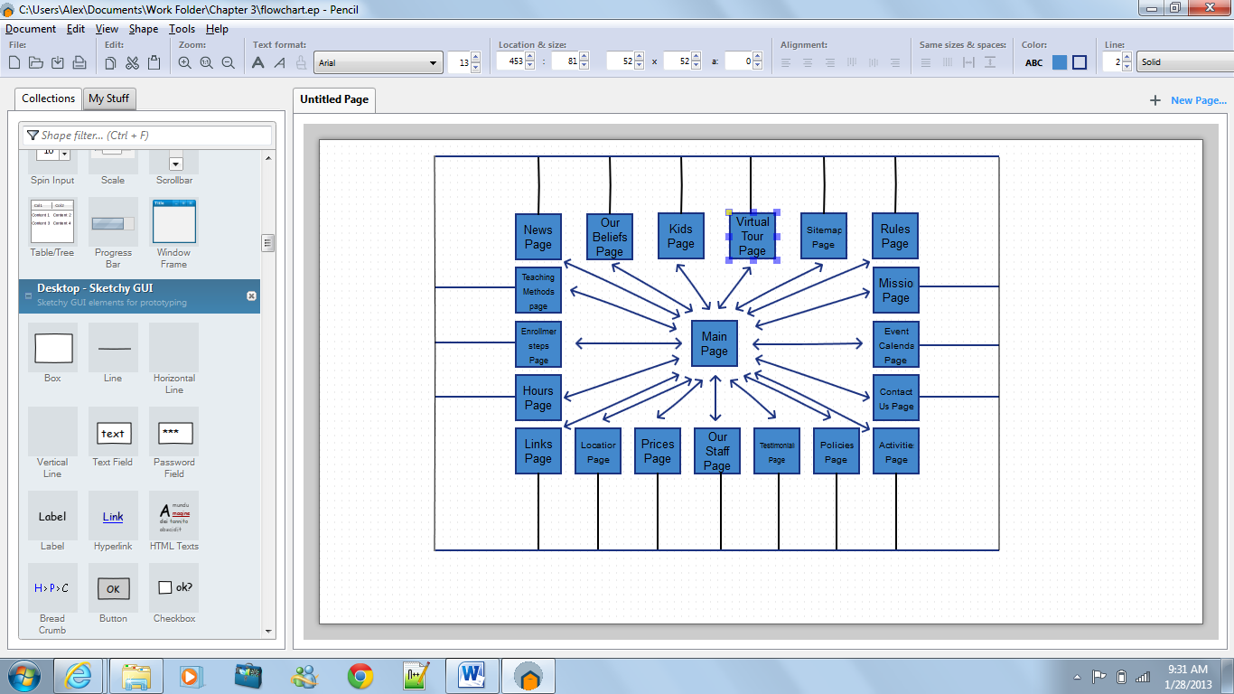

# Visual Diagrams:

Homepage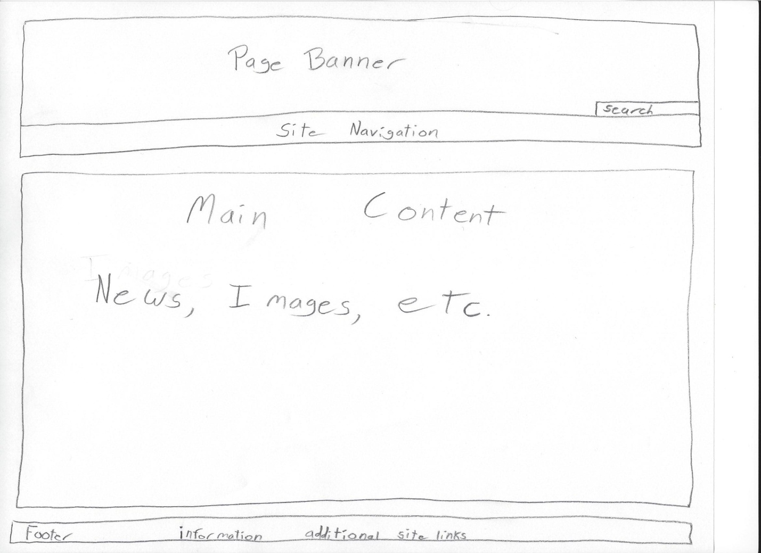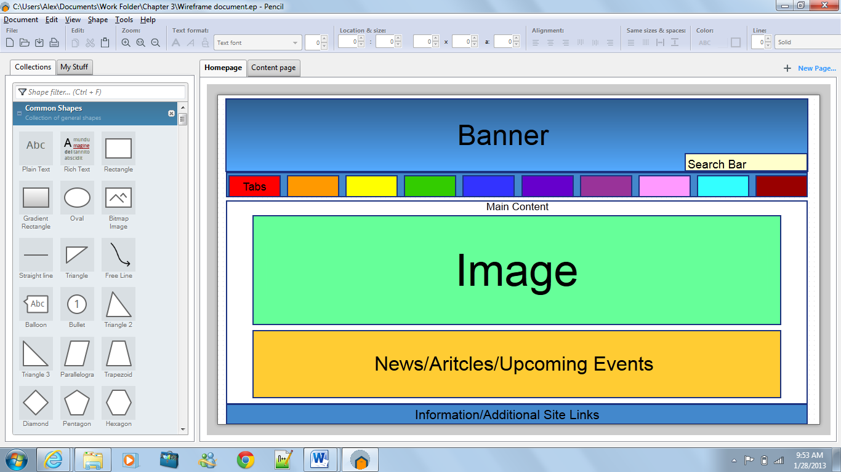

Secondary Page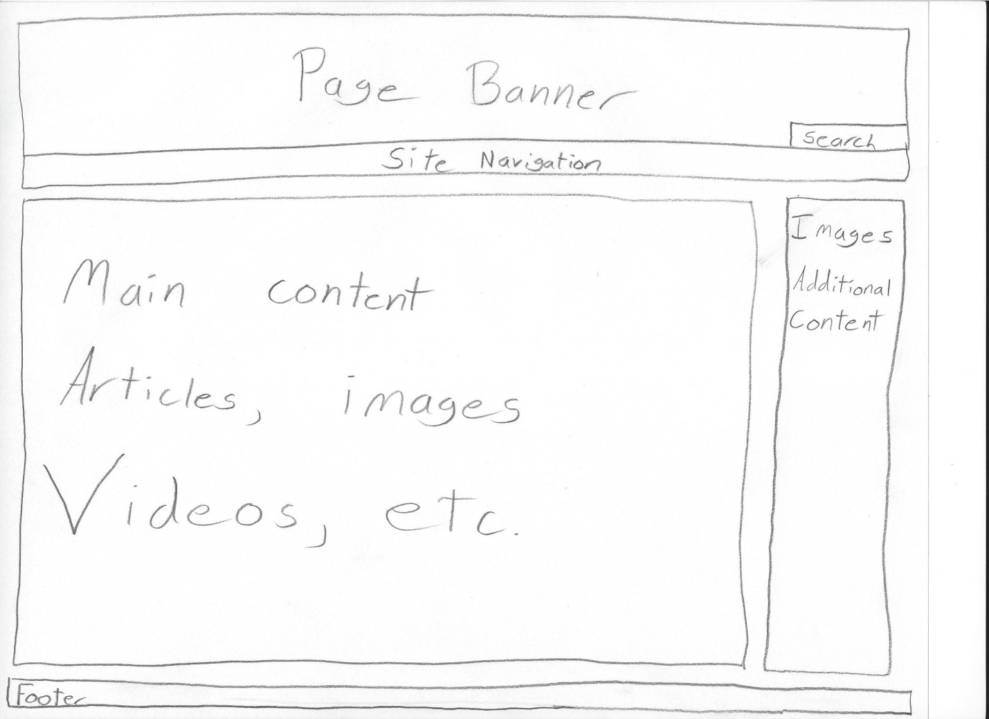

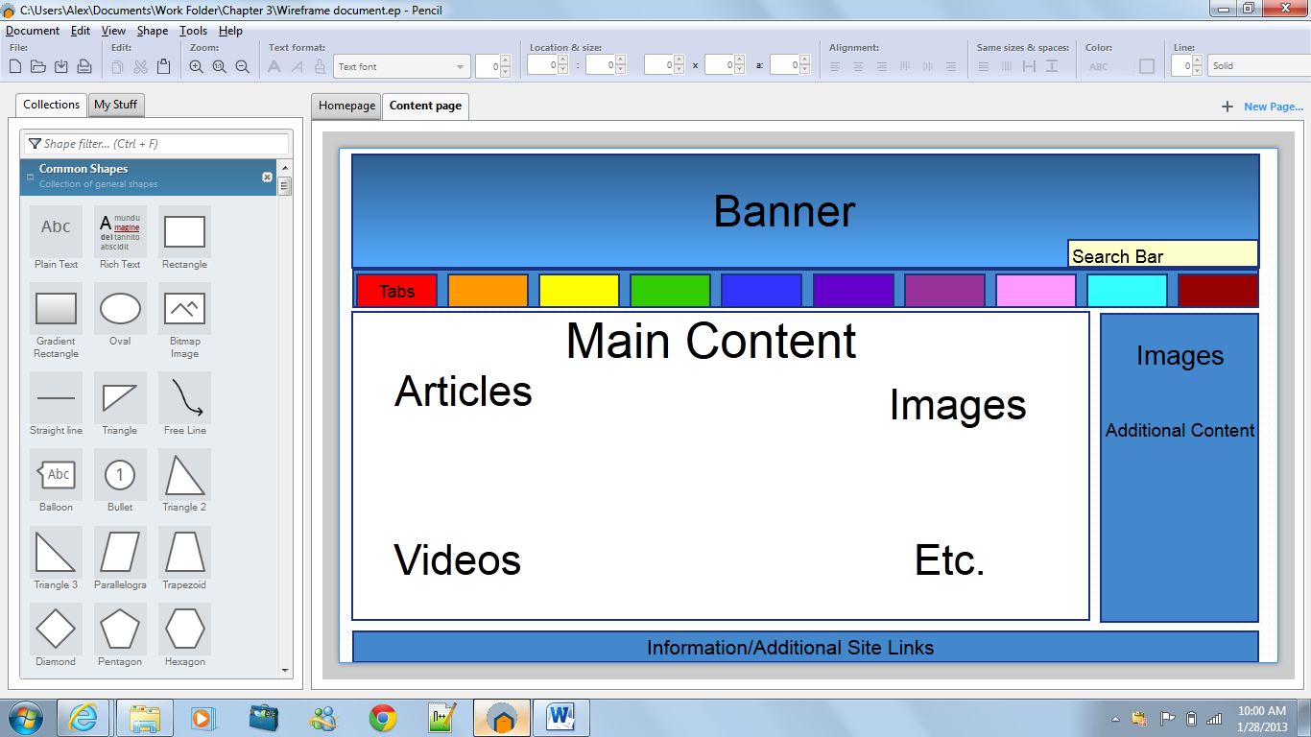

# Naming Convention:

I used the naming standard ISO 9660 which should work across all operating and file systems so we should have no trouble with the names of these files. I used a maximum of eight letters followed by a period and a three-letter extension. This will make it easier for the users and for me because at least the filenames will not cause any problems.

# Site Map:

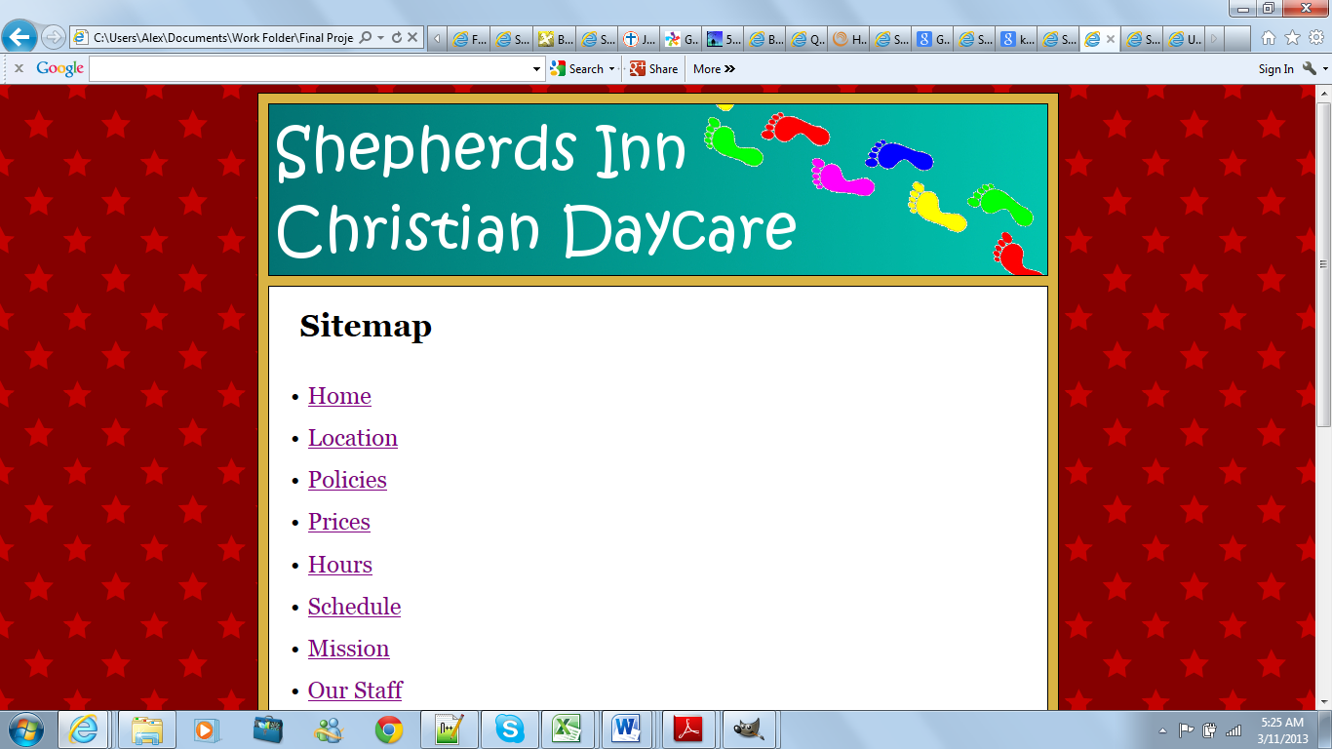 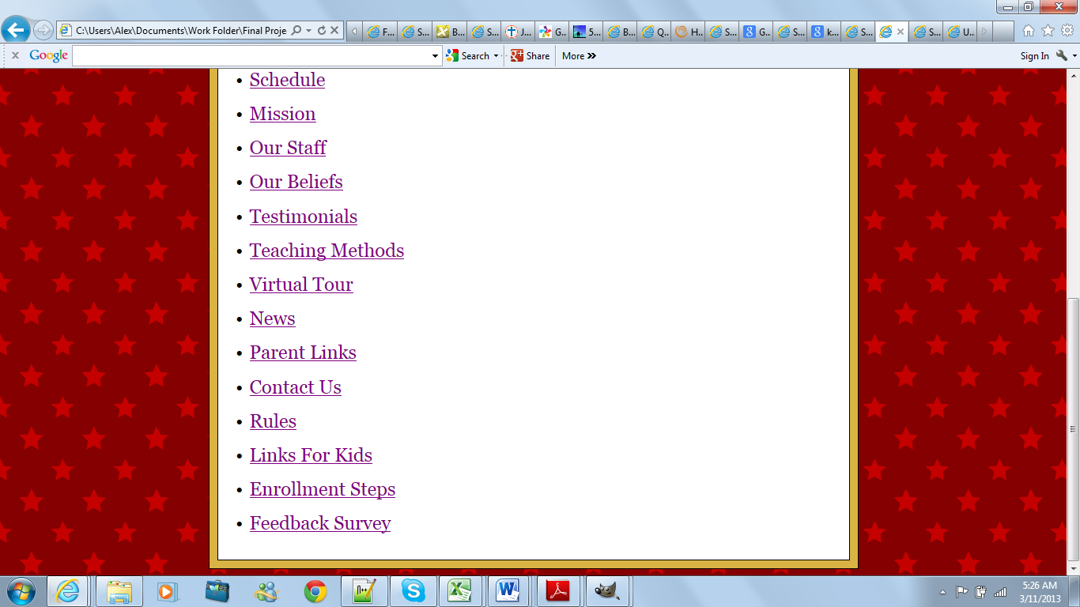

# Site Standards:

* Type specifications:
  + In all of the headings and also the paragraphs the font-family is Georgia with a backup font of Arial and then san-serif as an even further back up font.
  + The line spacing in the paragraphs is set to 1.5em to make the text a little easier to read.
  + The left and right margins of the paragraphs along with the heading2 element is 2em. The left margin of the heading1 element is 1em and the right margin is 2em.
* Box Properties:
  + Inside the wrapper everything has a 10px margin except for the space between the banner and the nav-bar which has no space.

Naming Standards

I used the naming standard ISO 9660 which should work across all operating and file systems so we should have no trouble with the names of these files. I used a maximum of eight letters followed by a period and a three-letter extension. This will make it easier for the users and for me because at least the filenames will not cause any problems.

Maintenance Plan for my Web site

Most of the pages will be checked for accuracy and updated monthly. The event calendar will be updated monthly or as needed if any special events are scheduled. The news section will be updated more or less than once a week depending on any news that may happen. The design and structure of the Web site will be reviewed monthly and if changes are desired or necessary, they will be put into effect as soon as conveniently possible. All links will be checked at least once a month and if staff or users notice a broken link it will be fixed immediately.

Testing for variables

Testing in different browsers:

I will test in the five major browsers which are Internet explorer, Firefox, Google Chrome, Safari, and Opera. I will test in older versions of these. In internet explorer, I will test from the current version which is 10 back to version 7. In Firefox, I will test from the current version which is 18 back to version 13. In Google Chrome, I will test from the current version which is 26.0 back to version 22. In Safari if I can find a mac to test on I will test from the current version which is 6.0.2 back to version 4 otherwise I will test from version 5.1.7 back to version 3. In Opera I will test from the current version which is 12 back to version 9.

Testing on different operating systems:

I will do my best to test on different operating systems such as windows xp, windows vista, windows 7, windows 8, snow leopard, lion, and mountain lion.

Testing with different screen resolutions:

I will test in 1366x768, 1360x768, 1280x768, 1280x720, 1280x600, 1024x768, and 800x600.

Testing on different connection speeds:

I will test on a few different connection speeds to see if the content displays properly and is not excessively slow.

I will test each of the different page layouts and any other things that may cause problems with different variables affecting them